The C program was tested by carrying out a set of experiments; and the C program output was verified successfully. For instance,

**Main menu:**

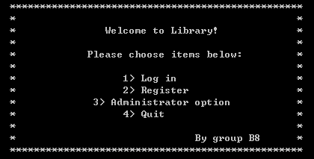

When open the program, main menu will display on the screen.

**Register function:**

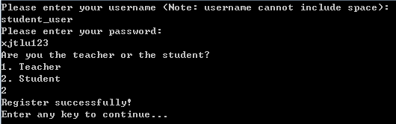

Student account

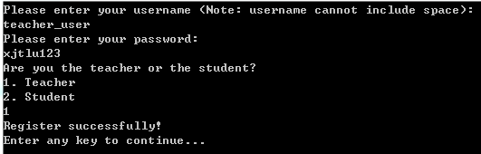

Teacher account

1. Enter user name.
2. Enter password.
3. Register teacher or student account. Enter 1 for teacher and 2 for student.

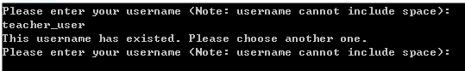

When register existed account, program will give notice to user to change the user name.

**Log in function:**

Now, there are two registered accounts in library system: student_user xjtlu123 and teacher_user xjtlu123

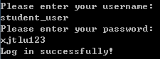

Log in student_user account

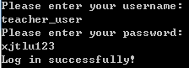

Log in teacher_user account

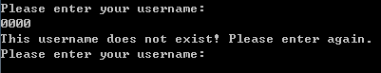

When enter the account which not exited in library system

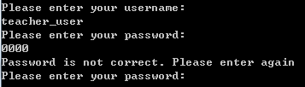

When enter wrong password

**Administrator option menu:**

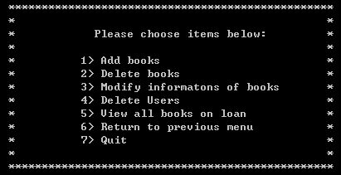

When choose Administrator option, this administrator will display on screen.

**Add books function:**

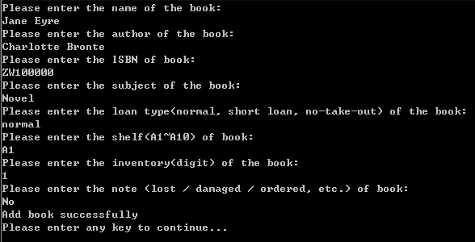

Add book << Jane Eyre>>

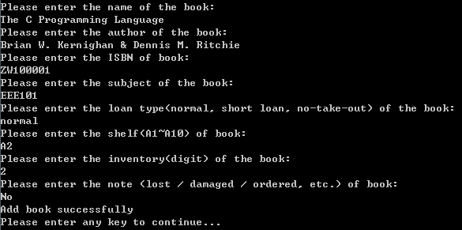

Add book <<The C Programming Language>>

1. Enter the book name
2. Enter the author
3. Enter the ISBN
4. Enter the subject
5. Enter the loan type
6. Enter the shelf area
7. Enter the inventory of the book(enter number)
8. Enter notes of the book

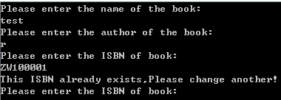

When enter existed ISBN, program will give notice to user to change another one.

**Delete books function:**

For testing this function, add a book at the beginning and search it, make sure this book add in the library, then use delete books function, finally, search it again, confirm this book was deleted.

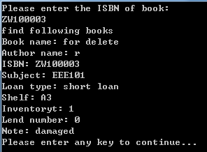

Add delete book

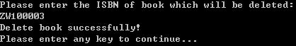

Use Delete books function

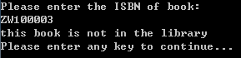

Delete successful

**Modify information of books function:**

For testing this function, add a book at the beginning and search it, record the details about this book, then use modify information of books function modify each information , finally, search it again, confirm the detail about this book was modified.

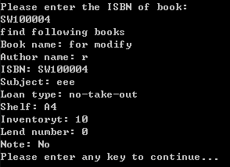

Original book

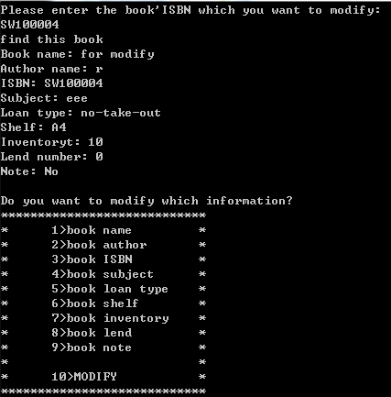

Use modify function

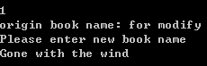

Modify book name

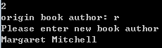

Modify book author

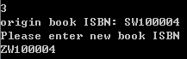

Modify book ISBN

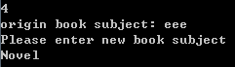

Modify book subject

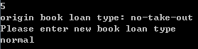

Modify book loan type

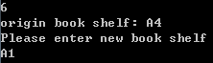

Modify book shelf

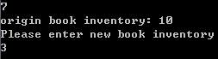

Modify book inventory

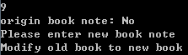

Modify book note



Choose MODIFY to finish modify part

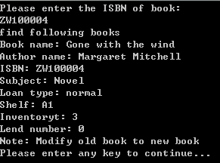

Modify successful

**Delete Users function:**

For testing this function, register a account at the beginning and record the details about this account, then use Delete Users function delete this account, finally, try to log in system use this account confirm it.

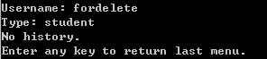

Account: fordelete Password: 123

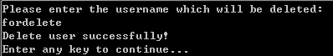

Use Delete User function

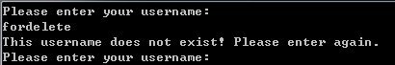

Delete successful

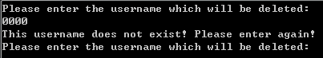

The function will give notice to user when this user account are not exist

**View all boos on loan function:**

For testing this function, loan a book at the beginning, then use View all books on loan function.



When there are no books on loan, this function will give notice to user.

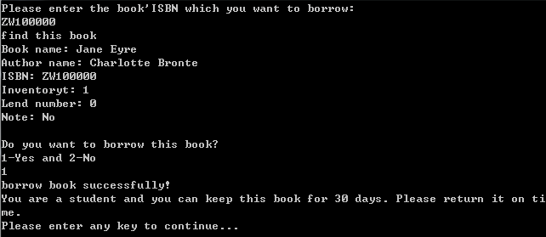

Borrow one book

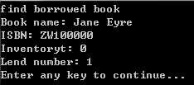

Use this function and display the books on loan

**Log in service menu:**

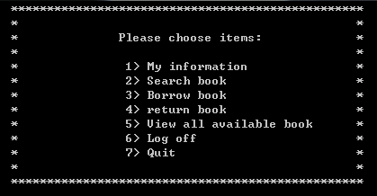

When log in successful, this service menu will display

**My information function**

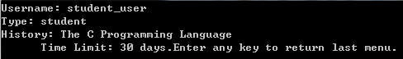

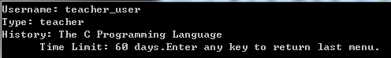

User could check their user name, user type and borrow book history

**Search book function:**

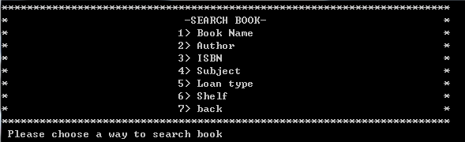

Search book menu

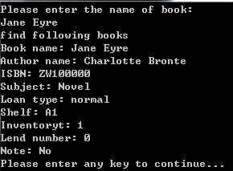

Use book name to search

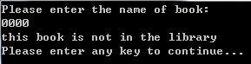

When this book are not in the library

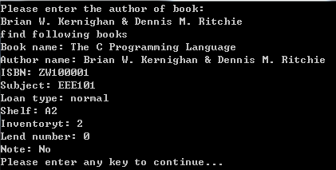

Use book author to search

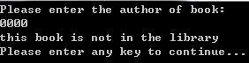

When this book are not in the library

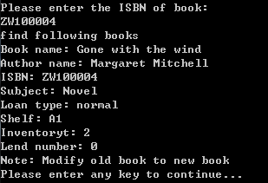

Use book ISBN to search

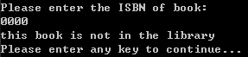

When this book are not in the library

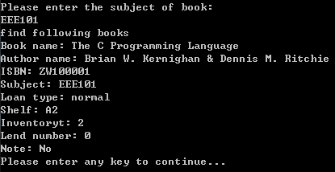

Use subject to search

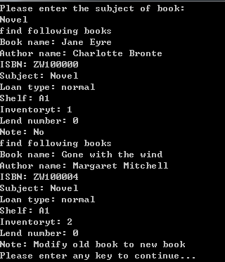

Use subject to search

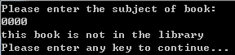

When this subject not in the library

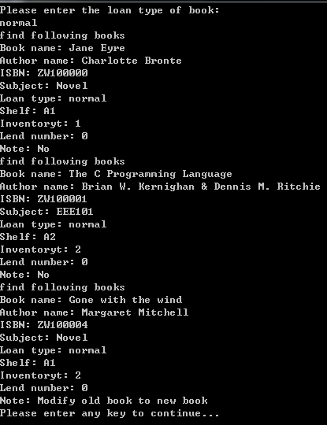

Use loan type to search

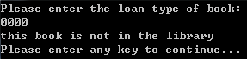

When this type not in the library

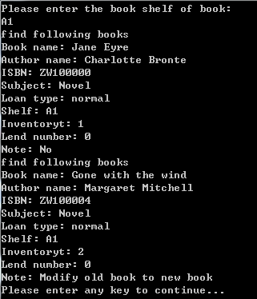

Use book shelf to search

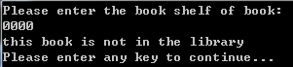

When this library do not have this shelf

**Borrow book function:**

For testing this function, search a book at the beginning and record the inventory of this book, then borrow this book, finally, search it again to compare the inventory and lend number.

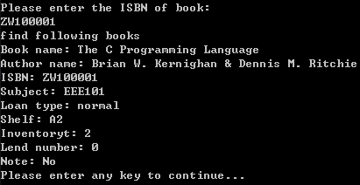

Inventory is 2

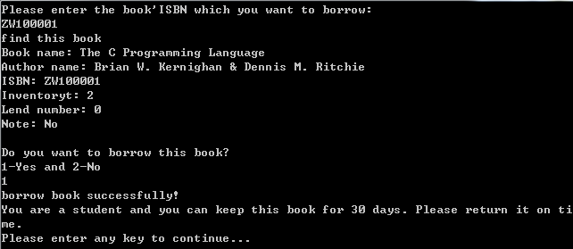

Borrow successful (student account)

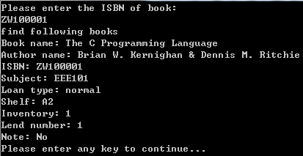

Inventory is 1 and land number is 1

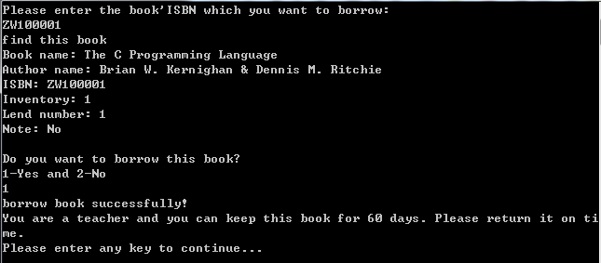

Borrow successful (teacher account)

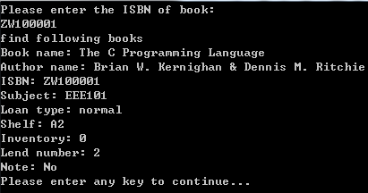

Inventory is 0 and land number is 2

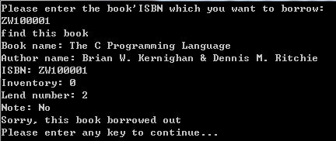

When inventory equal to 0, user cannot borrow this book

**Return book function:**

For testing this function, search a book which borrowed by user at the beginning and record the lend number of this book, then return this book, finally, search it again to compare the inventory and lend number.



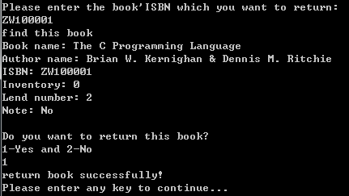

Return successful

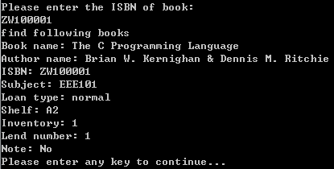

Inventory is 1 and lend number is 1

**View all available book function:**

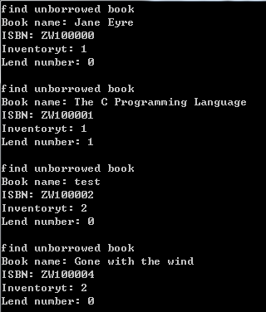

This function will display all available books



If there are not available books, this function will give notice to user

**ALL**